**AONTAS 2015 STAR Awards**

Killarney Adult Basic Education Centre has been shortlisted for the AONTAS 2015 STAR Awards with their project ‘The Power of Partnership’.

‘The Power of Partnership’ is based on the radio play ‘The Let Down’. This programme came about as a result of a themed literacy programme about Tom Crean. One of the learners wrote the play.

This project is an example of how organisations (Killarney ABE, Lime Grove Recovery and Therapeutic Centre and Radio Kerry) working together results in a positive learning outcome for the learners.

The next phase of the judging process involves meeting the judging panel on the 5th February, 2015 and the overall STAR awards ceremony will be held in Dublin on the 23rd February, 2015.

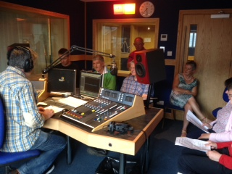 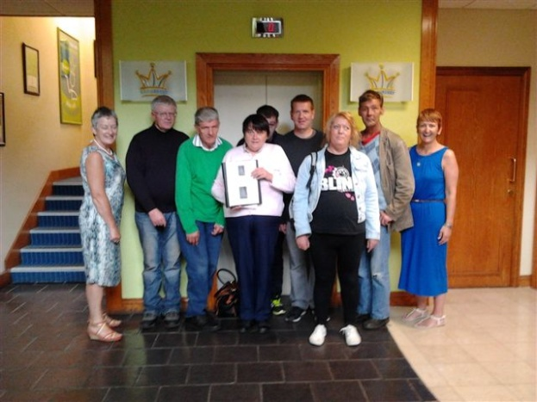

Recording Studio – Radio Kerry ‘The Group’ at Radio Kerry

